Research Project Assignment – REV
First M Last
Embry Riddle Aeronautics University
Professor X
April 29. 2017

Abstract

- Cloud Computing
- Mobile Infrastructure
- Computer Integrated Manufacturing (CIM)

Conclusion

References

Footnotes
1Add footnotes, if any, on their own page following references. The body of a footnote, such as this example, uses the Normal text style. (Note: If you delete this sample footnote, don’t forget to delete its in-text reference as well. That’s at the end of the sample Heading 2 paragraph on the first page of body content in this template.)

Tables
Table 1
Table Title
Column Head | Column Head | Column Head | Column Head | Column Head
Row Head | 123 | 123 | 123 | 123
Row Head | 456 | 456 | 456 | 456
Row Head | 789 | 789 | 789 | 789
Row Head | 123 | 123 | 123 | 123
Row Head | 456 | 456 | 456 | 456
Row Head | 789 | 789 | 789 | 789
Note: Place all tables for your paper in a tables section, following references (and, if applicable, footnotes). Start a new page for each table, include a table number and table title for each, as shown on this page. All explanatory text appears in a table note that follows the table, such as this one. Use the Table/Figure style, available on the Home tab, in the Styles gallery, to get the spacing between table and note. Tables in APA format can use single or 1.5-line spacing. Include a heading for every row and column, even if the content seems obvious. A table style has been setup for this template that fits APA guidelines. To insert a table, on the Insert tab, click Table.

Figures
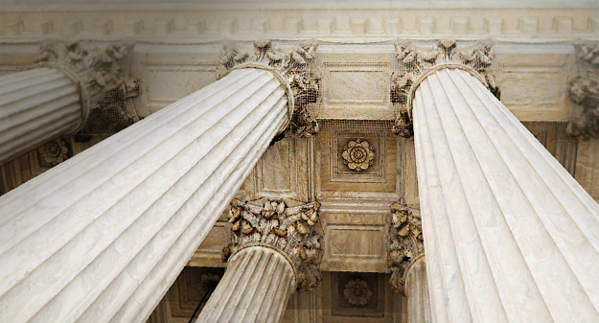
Figure 1. Include all figures in their own section, following references (and footnotes and tables, if applicable). Include a numbered caption for each figure. Use the Table/Figure style for easy spacing between figure and caption.
For more information about all elements of APA formatting, please consult the APA Style Manual, 6th Edition.

